**Tutt Middle School**

**Spanish Exploratory – 2025-2026**

**Mr. Rivera, Leonardo**

**What to Bring to the Spanish Class Every Day**

**Supplies List**

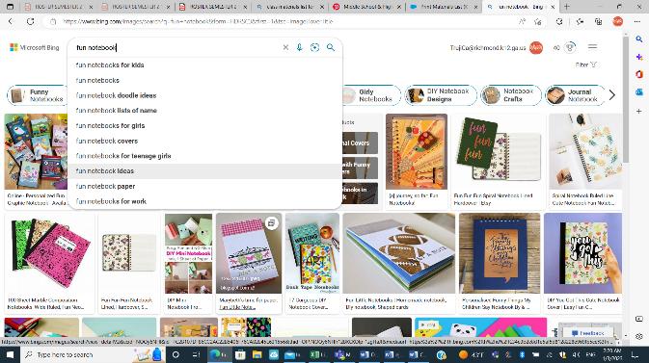

* 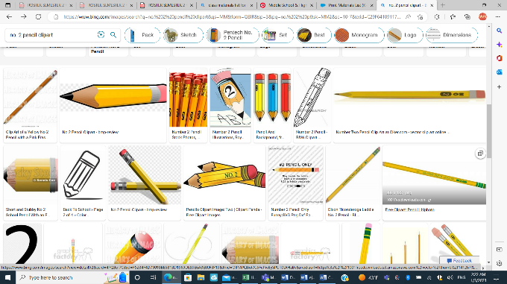Notebook
* Pre-Sharpened Pencils (No. 2)
* 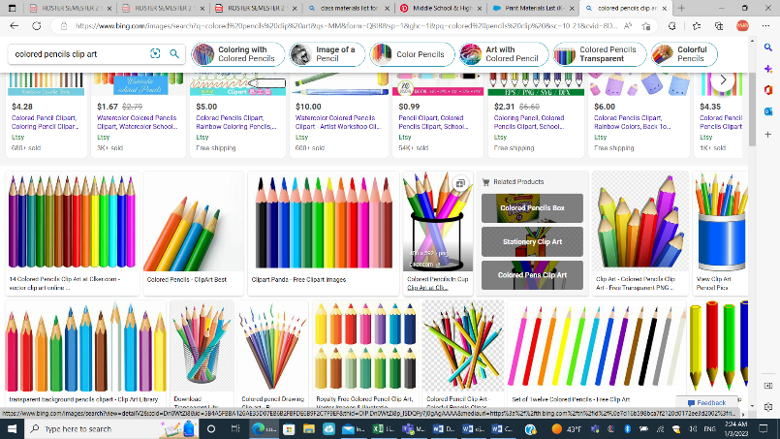Colored pencils
* 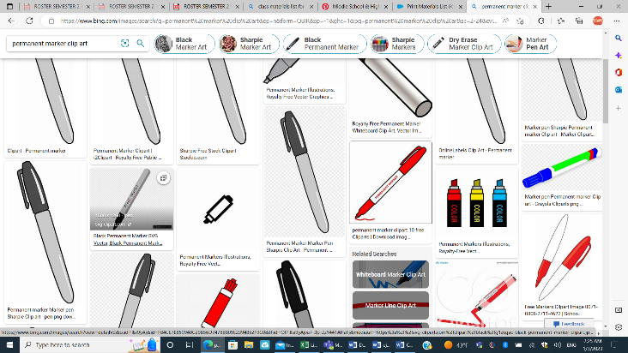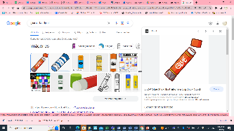Permanent Markers
* Glue Sticks
* 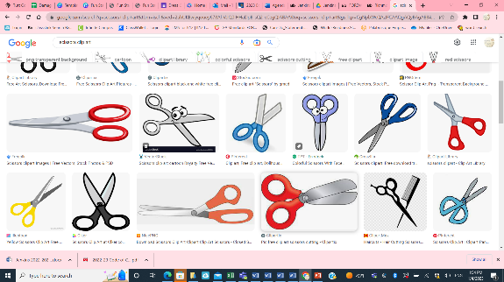scissors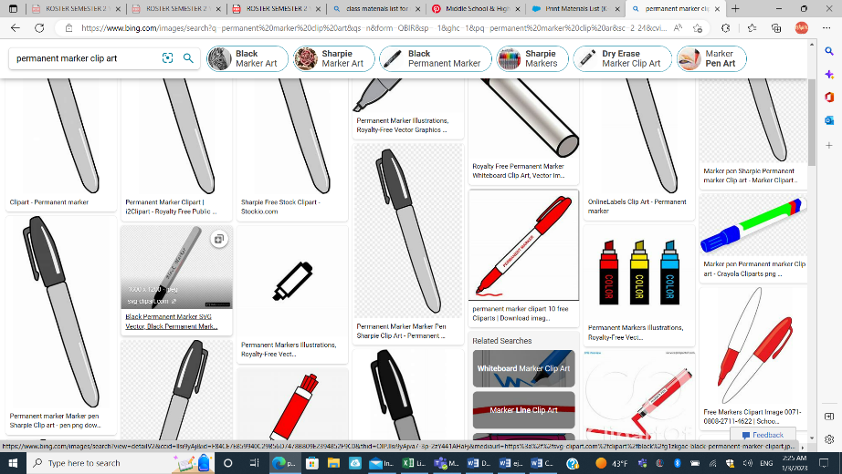
* 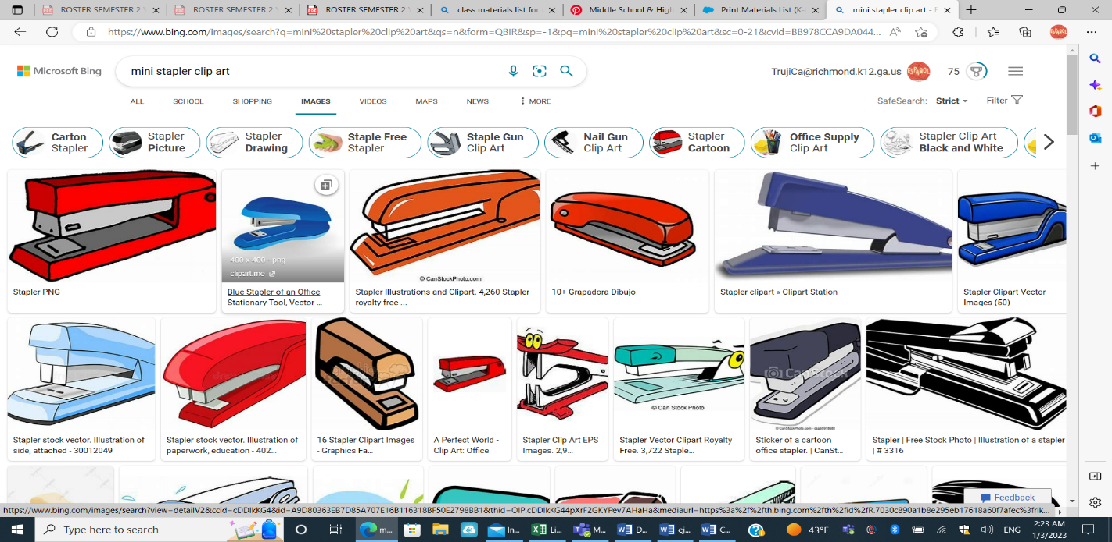Highlighters
* 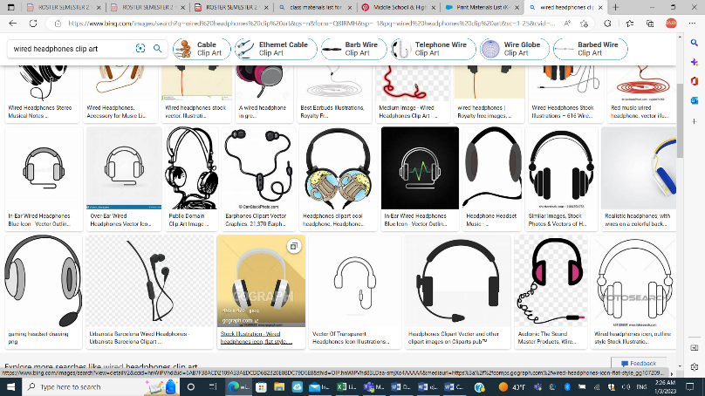Mini stapler
* Wired headphones (No air pods or Bluetooth devices).

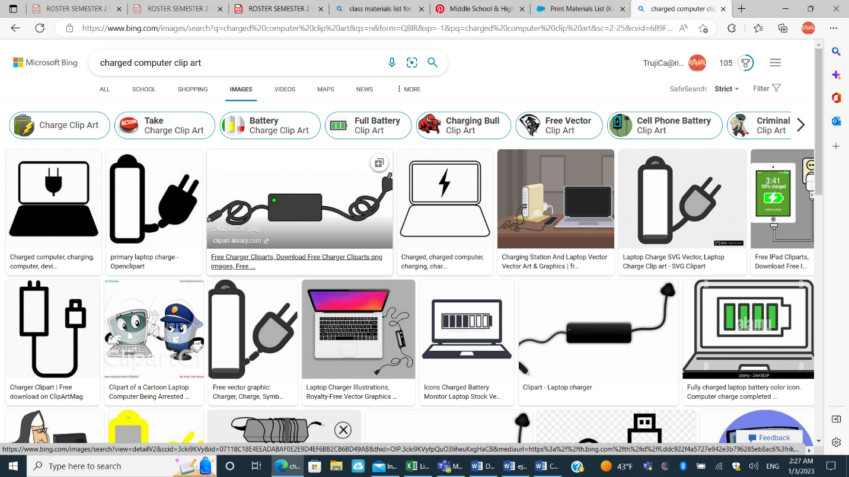*If the student can’t bring a headphone, the teacher will assign one to use during class.*

Important: Computer – Student must bring a charged computer to the Spanish class

Note: Supplies in the classroom are limited and will have to be shared with each other unless they bring supplies of their own.